

**Green University of Bangladesh**

**Department of Computer Science and Engineering(CSE)**

**Faculty of Sciences and Engineering**

**Semester: (Summer, Year:2022), B.Sc. in CSE (Day)**

**Assignment 03**

**Course Title: Structured Programming**

**Course Code: CSE 103 Section: DE**

**Student Details**

|  |  |
| --- | --- |
| **Name** | **ID** |
| **Md. Israil Fakir** | **221902125** |

**Submission Date : 11-Sep-22**

**Course Teacher’s Name : Mahbubur Rahaman**

**[For Teachers use only: Don’t Write Anything inside this box]**

|  |
| --- |
| **Lab Report Status**  **Marks: ………………………………… Signature:.....................**  **Comments:.............................................. Date:..............................** |

**Problem 01: Access each character of a string and print separately.**

**Code:**

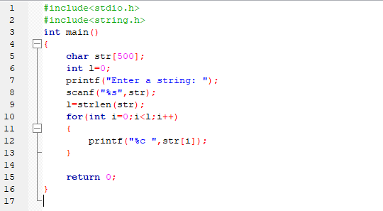

**Output:**

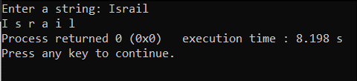

**Problem 02: Compare two strings (same or not).**

**Code:**

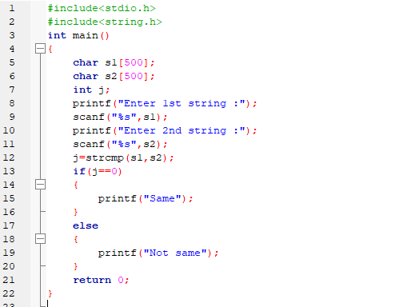

**Output:**

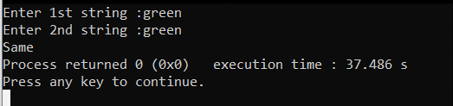

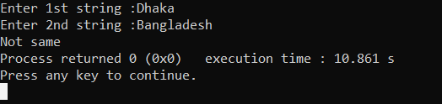

**Problem 03: Reverse a string**

**Code:**

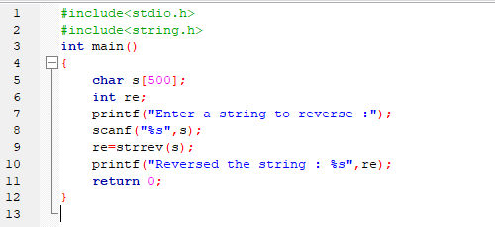

**Output:**

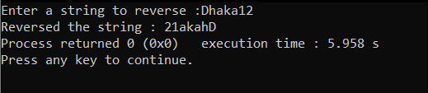

**Problem 04:** **Concatenate string without strcat()**

**Code:**

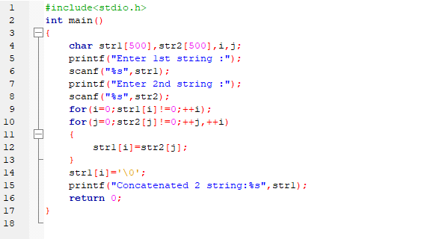

**Output:**

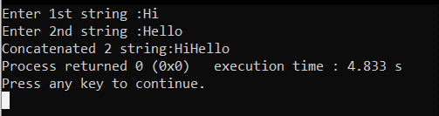

**Problem 05:** **Find Out number of total characters in a string.**

**Code:**

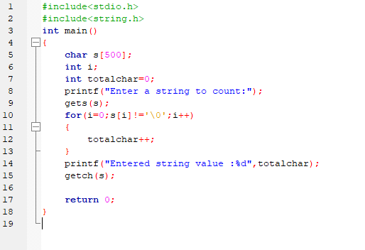

**Output**

**:**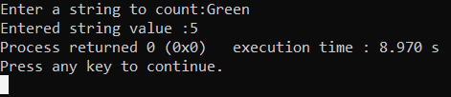

**Problem 06:** U**se the functions strcpy(),strcmp(),stccat(),strncpy()**

**strcpy()**

**Code:**

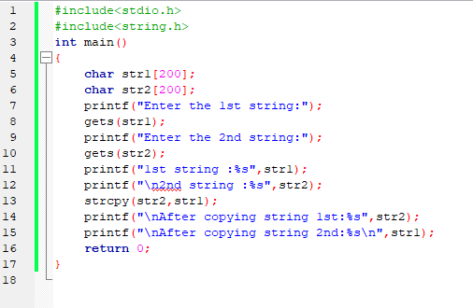

**Output:**

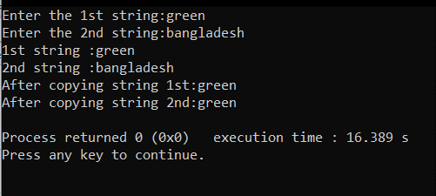

**strcmp()**

**Code:**

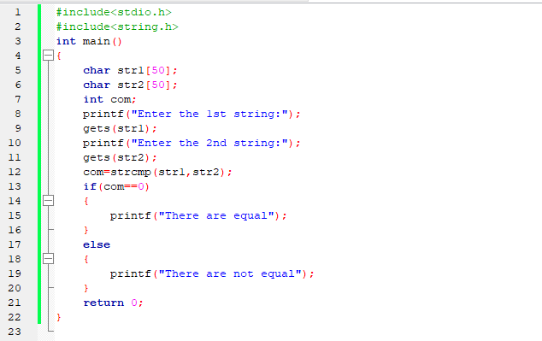

**Output:**

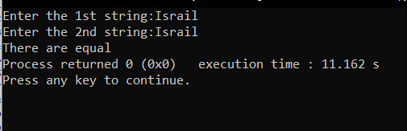

**stccat()**

**Code:**

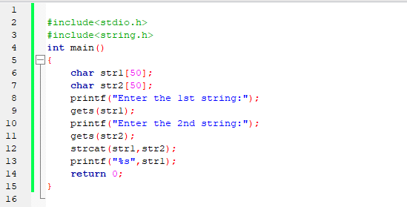

**Output:**

